**East West University**

**Lab Report**

**Semester:** Summer-2024

**Course Title:** Electrical Circuits **Course Code:** CSE209

**Sec:** 01

**Expt No: 07**

**Expt Name: Experimental Study of Sinusoids and Their Characteristics**

**Group No: 07**

**Group Members:**

|  |  |
| --- | --- |
| **Student Name** | **Student Id** |
| **Shiekh Sarafat Hossain** | **2022-3-60-109** |
| **Rijia Parveen Raya** | **2022-3-60-192** |
| **Esrat Jerin** | **2022-3-60-218** |
| **Nadira Akter** | **2022-3-60-220** |
|  |  |

**Submitted by-**

Name: Sheikh Sarafat Hossain

Id: 2022-3-60-109

**Submitted to-**

Dr. Sarwar Jahan

Associate Professor

Department of Computer Science & Engineering

East West University

**Date of Performance: 08-September-2024**

**Date of Submission: 15-September-2024**

**Experiment Name: Experimental Study of Sinusoids and Their Characteristics**

**Objectives:**

* Observing the sinusoids in the oscilloscope using a simple RC circuit.
* Reading characteristics of the sinusoid from the oscilloscope and matching the values with their corresponding measured values.

**Theory:**

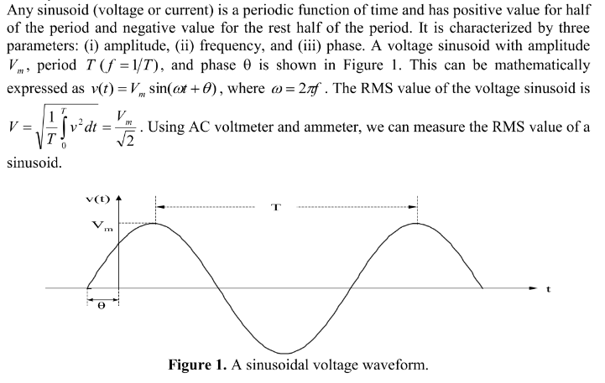

**Measured of phase differences in oscilloscope:**

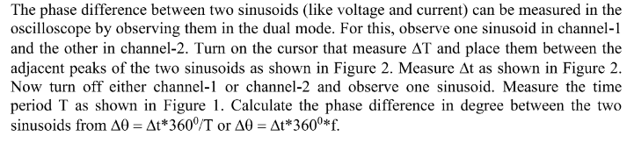

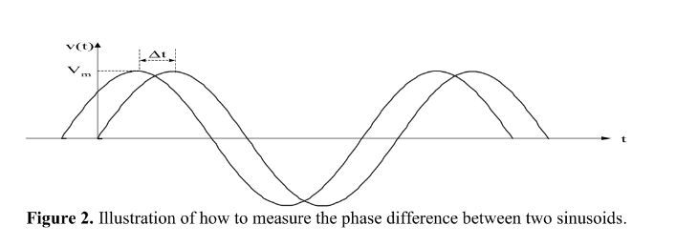

**Impedance:**

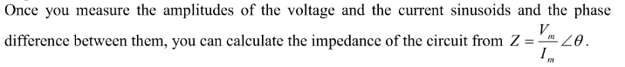

**Circuit Diagram:**

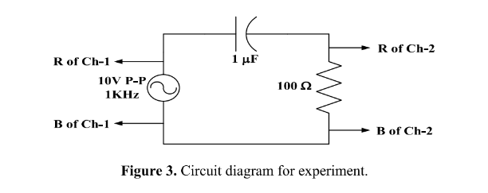

**Equipment and Components Needed:**

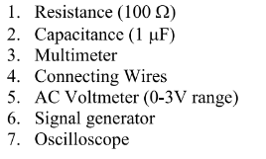

**Experimental Data:**

**Table 1: Experimental data from oscilloscope.**

|  |  |  |  |  |  |
| --- | --- | --- | --- | --- | --- |
| Measured value of resistance(Ω) | Peak-to-peak value of source voltage(V) | Source frequency (KHz) | Peak values of current through resistance (mA) | Measured Phase difference between voltage and current (deg) | Which signal is leading? |
| 102.05 | 10.4 | 1.00 | 49 | 64.8 | 2 |

**Table 2: Experimental data from Meter reading.**

|  |  |  |  |
| --- | --- | --- | --- |
| Measured RMS value of source voltage(V) | Measured RMS value of voltage across capacitor(V) | Measured RMS value of voltage across resistance(V) | RMS value of current through resistance(mA) |
| 3.52 | 2.97 | 1.68 | 1.76 |

**Discussion and Analysis:**

|  |  |  |
| --- | --- | --- |
| **Units** | **Lab data** | **Experimental Data** |
| Resistance (Ω) | 100 | 102.05 |
| Source frequency (KHz) | 1.00 | 1.00 |
| Peak values of current through resistance (mA) | 53 | 49 |
| Phase difference between voltage and current (deg) | 57.86 | 64.8 |
| Which signal is leading? | Current (I) leads voltage (V) | I |

Here frequency is totally same but, rest of the parts have slightly differences.

**Answer of Post Lab Questions**

1. **Divide the amplitude of the signal generator voltage measured by the oscilloscope by $√2$ and compare it with the measured RMS value by voltmeter.**

**Solution:**

Peak to peak value of source voltage (V) is 5.00, and this is measured by oscilloscope.

And if we divide it by $\sqrt{2}$ then the desired value will be,

$\frac{5.00}{\sqrt{2}}$ = 3.54 V

The measured RMS value of source voltage (V) is 3.53 V

Discrepancy is about 0.01 V, which is negligible.

1. **Divide the amplitude of the current measured by the oscilloscope by $√2$ and compare it with the measured RMS value.**

**Solution**:

Calculated RMS value = 49/ $\sqrt{2}$ = 34.64 mA

Measured RMS value of current through resistance = 1.76 mA

1. **Calculate the impedance by the measured values of voltage and current from the oscilloscope. Also calculate the impedance from Z = R-jXc.**

**Solution:**

Impedance = V/I

= 5.00/50.4 = 102.04 Ω

Angular frequency = 2πf = 2 X 3.1416 X 1000 = 6283.2 rad/sec

Xc = j/(ωc) = j159.15

Z = R - j Xc = (102.04 – j159.15) Ω

1. **Calculate the impedance angle from the expression tan-1(Xc/R) and compare it with the phase difference measured from the oscilloscope.**

**Solution:**

Impedance angle = $\tan^{-1}(Xc /R)$

= $\tan^{-1}(159.15/102.04 )$

= 57.33 degree

Measured phase difference = 64.8 degree

Phase Difference = (57.33 – 64.8) = -7.46 degree

**Discussion:**

